**Cloud based Student Chatbot**

**A COURSE PROJECT REPORT**

***Submitted by***

* **MOHAMED RIZWAN(RA2011029010014)**
* **NALLA RAJESH(RA2011029010030)**
* **UDARAPU CHANDU(RA2011029010058)**

*Under the guidance of*

### Dr.P.VISALAKSHI

(Asst.Professor, Department of Network and communications)

**BACHELOR OF TECHNOLOGY**

in

### NETWORK AND COMMUNICATIONS

of

#### FACULTY OF ENGINEERING AND TECHNOLOGY

S.R.M. Nagar, Kattankulathur, Chengalpattu District

**October 2022**

**Abstract**

* We are aiming to build a chatbot for answering college-related queries that are frequently asked by students. Students have a lot of queries, and the queries are quite different. They need answers to their queries quickly but, this is not possible as they need to browse through the entire website or approach Admins, which is both takes more time and work. Hence to facilitate this process, we need to automate this process. Our chatbot will serve this purpose efficiently by giving the most appropriate answers to the queries
* Cloud based Student Chatbot is an artificial algorithm that analyse the student’s queries and messages. This system has a built artificial intelligence to answer the query of the student. To answer to the student query, the Chatbot system retrieves the answer from the database which is stored in the cloud. The Chatbot system uses a specific keyword to retrieve the answers from the database. There is no format for the student to follow while asking any question in the Chatbot. The students can put up any query related to college activities through the system. The system helps the student not only to get their queries answered but also to be updated with the college activities.

**Advantages:**

* Students does not have to go personally to college office for the enquiry.
* This application enables the students to be updated with college activities.
* This application saves time for the student as well as teaching and non-teaching staffs.

**Disadvantages:**

* Requires an active internet connection to connect with cloud server.

**Innovative ideas:**

We aim to build a chatbot which in WhatsApp Twilio API because students don’t need to install separate application for it and we modify the chat Amazon Lex enables you to easily publish your voice or text chatbots for use on mobile devices, web apps, and chat services. Amazon Lex scales automatically so you don’t need to worry about provisioning hardware and managing infrastructure to power your bot experience and we are using AI algorithm which makes the chatbot constantly learn things and this application is build

**How To Do:**

* **Students ask their query to the chatbot**
* **Chatbot uses AI algorithm to understand the question**
* **Chatbot Checks the database for answer and answer the question**
* **If the answer is not there it notify the admin and the admin update the database.**

**C**

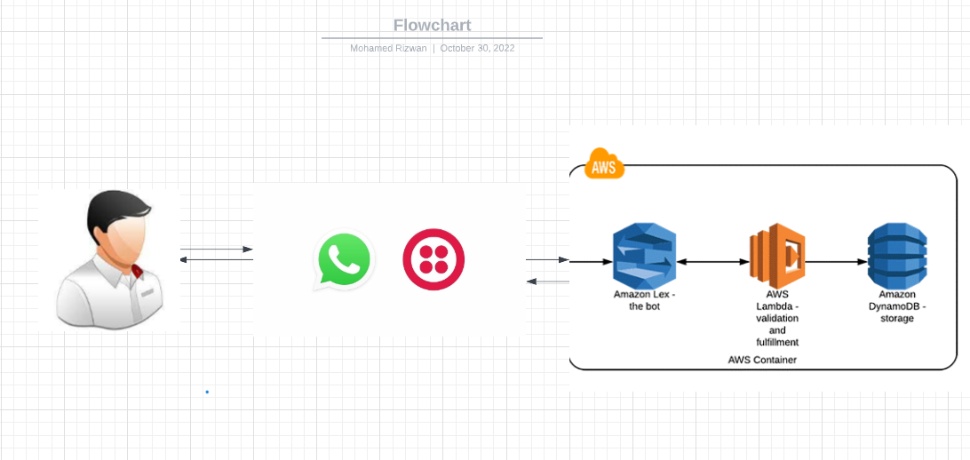

**Data Flow Diagram:**

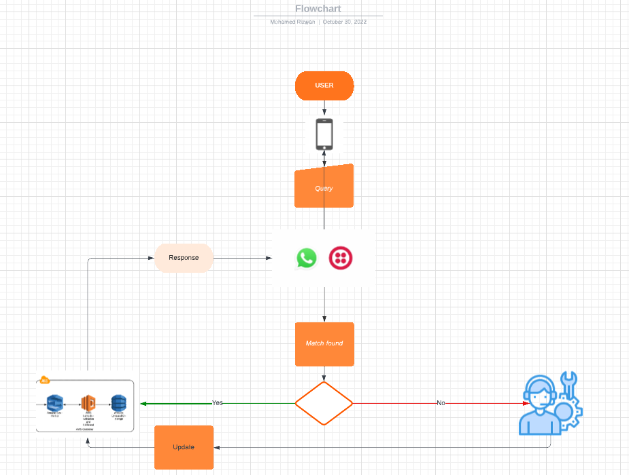

**Technology used:**

AI-enabled chatbots rely on NLP to scan users’ queries and recognize keywords to determine the right way to respond. Additionally, some AI-based chatbots also benefit from ML integration and so can self-improve through repeated interaction with users’ data – as new training data – in order to expand the knowledge database and improve the relevancy and accuracy of their responses.

Natural Language Processing: enables chatbots to convert users’ text and speech into structured data to be understood by a machine. The NLP process consists of the following steps:

Natural language understanding (NLU) is a subfield of NLP which focuses on understanding the meaning of human speech by recognizing patterns in unstructured speech input. NLU solutions have 3 components:

NLU enables chatbots to classify users’ intents and generate a response based on training data.

Natural language generation (NLG) is the process of transforming machine-produced structured data into human-readable text. After understanding users’ intent NLG has 4 steps to generate a response:

AWS LEX: Amazon Lex chatbots convert incoming speech to text and understand the user intent to generate an intelligent response, so you can focus on building your bots with differentiated value-add for your customers, to define entirely new categories of products made possible through conversational interfaces.

AWS LAMBDA: The Lambda function can validate the response and provide corrective feedback to the user, if necessary. For fulfilment, Amazon Lex invokes the Lambda function to fulfil the user request after the bot successfully collects all of the required information and receives confirmation from the user.

Conclusion:

So, we build a chatbot with Twilio API and AWS as cloud Service for student regarding the query related to classes and the college. Students have no longer rely on other for query, they can just ask the chatbot which time saving and super-fast and correct information. Query can be anything regarding the college which the chatbot can answer ,it is built with AI algorithms which makes it to learn things from the query students ask.